**AP Macro 1.1 Scarcity & Opportunity Cost**

1. Which of the following is an example of a factor of production?

(A) A want

(B) A bank

(C) A bond

(D) Capital

(E) Stock

1. Which of the following is the most fundamental issue that economics addresses?

(A) Choice of appropriate technology

(B) Reduction of unemployment

(C) Reduction of budget deficit

(D) Promotion of privatization

(E) Use of scarce resources

1. The concept of opportunity cost would no longer be relevant if

(A) poverty in an economy no longer existed

(B) the supply of all resources were unlimited

(C) resources were allocated efficiently

(D) real wages were flexible

(E) all current incomes were invested in technological research

1. 4. In which of the following situations is a good NOT scarce?

(A) Consumer give up nothing to obtain more of the good.

(B) Consumer can purchase as much of the good as they want at its current market price.

(C) Large quantities of the good are available in the marketplace.

(D) There is a surplus of the good at some positive price.

(E) There is a shortage of the good at some positive price.

1. 5. As a factor of production, capital refers to the

(A) money available to start a business

(B) stocks and bonds issued by businesses to raise funds

(C) financial investment of businesses

(D) currency in circulation and deposits in financial institutions

(E) tools and machinery used to produce goods and services

1. An opportunity cost is entailed in which of the following situations?

[I]A student decides to attend college full-time

[II]A family uses its $20, 000 savings to purchase an automobile

[III] A farmer decides to grow more wheat and less corn.

(A) I only

(B) II only

(C) III only.

(D) I and III only

(E) I, II and III

1. Resources are

(A) Scarce for households but plentiful for economies.

(B )Plentiful for households but scarce for economies

(C) Scarce for households and scarce for economies.

(D )Plentiful for households and plentiful for economies.

(E )Plentiful for both if human can avoid the waste

1. The adage, "There is no such thing as a free lunch, " means

(A) Even people on welfare have to pay for food

(B)The cost of living is always increasing

(C)People face tradeoffs

(D )All costs are included in the price of a product.

(E) Goods are scarce

1. Which of the following is correct concerning opportunity cost?

(A)Except to the extent that you pay more for them, opportunity costs should not include the cost of things you would have purchased anyway

(B)To compute opportunity costs, you should subtract benefits from costs

(C) Opportunity costs and the idea of tradeoffs are not closely related

(D)Rational people should compare various options without considering opportunity costs

(E)None of them.

**AP Macro 1.2 Production possibility curve**

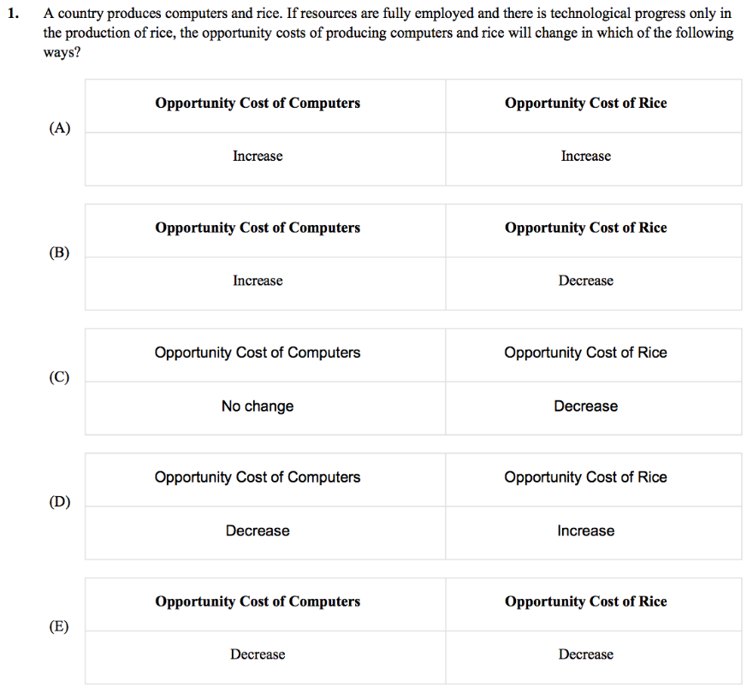

1. A linear production possibilities curve indicates which of the following?

(A) Constant opportunity costs

(B) Decreasing opportunity costs

(C) Increasing opportunity costs

(D) Diminishing marginal returns

(E) Labor-intensive production

1. Where on a graph of a production possibilities curve would a point showing that an economy is using its resources efficiently be located?

(A) On the production psisibitis curve

(B) Inside the production possibilities curve

(C)Beyond the production possibilities curve

(D) On the y-axis and below the production possibilities curve

(E) On the x-axis and below the production possibilities curve

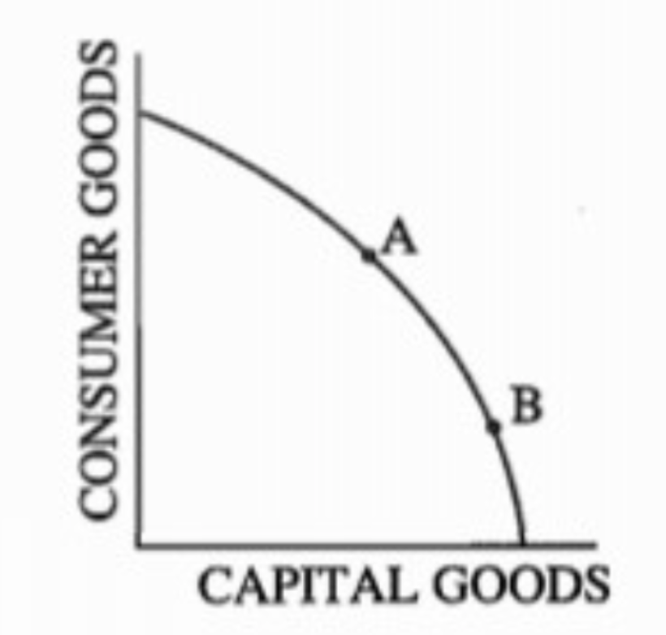

The diagram above shows an economy's current production ossibilies curve for capital goods and consumer goods. If society chooses point B over point A, society is choosing

(A) more future consumption in exchange for less current consumption

(B) more current capital goods in exchange for less future consumption

(C) more future and current consumption

(D) less future consumption in exchange for more current consumption

(E) less current capital goods in exchange for greater future consumption

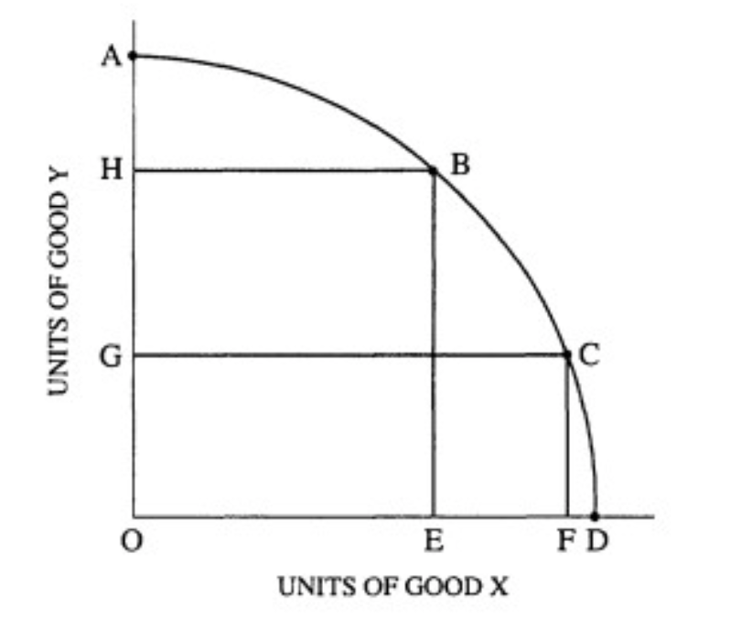

The graph above shows an economy's production possibility frontier for the production of two goods, x andY. Assume that the economy is currently at point B. The opportunity cost of moving from point B to point C is

(A) AH units of good Y

(B) HG units of good Y

(C) OG units of good Y

(D) EF units of good x

(E) OF units good x

1. Improvements in technology for producing all goods must result in

(A) an inward shift in the production possibilities curve

(B) an outward shift in the production possibilities curve

(C) a fatter production possibilities curve

(D) a steeper production possibilities curve

(E) greater unemployment of labor

1. An outward shift in the production possibilities curve of an economy can be caused by an increase in

(A) unemployment

(B) the labor force

(C) inflation

(D) output

(E) demand

8. Which of the following explains why a production possibilities curve is often represented as concave (bowed out) from the origin?

(A) The law of demand

(B) The law of supply

(C) Constant returns to scale

(D) Decreasing opportunity cost

(E) Increasing opportunity cost

1. Assume that an economy produces televisions and shoes. Which of the following would cause the production possibilities curve for this economy to shift outward?

(A) An increase in the labor force

(B) An increase in the prices of both goods

(C) An increase in the prices of resources used to produce both goods

(D) A decrease in the demand for shoes

(E) A change in consumers' tastes in favor of televisions

10. An economy produces two goods: x and Y. Its production possibilities curve is linear with the intercept on the Y axis at 1,000 units and the intercept on the x axis at 100 units. Which of the following statements is correct?

(A) There is an increasing opportunity cost of producing good x, beginning with 1 unit of x costing 0.1 unit of Y.

(B) There is an increasing opportunity cost of producing good Y but not of producing good x, which has a constant opportunity cost.

(C) There is a constant opportunity cost with each unit of good x costing 10 units of good Y.

(D) There is a constant opportunity cost with 10 units of good x costing I unit of good Y.

(E) With a linear production possibilities curve, total production of goods x and Y will be the same at each point on the curve.

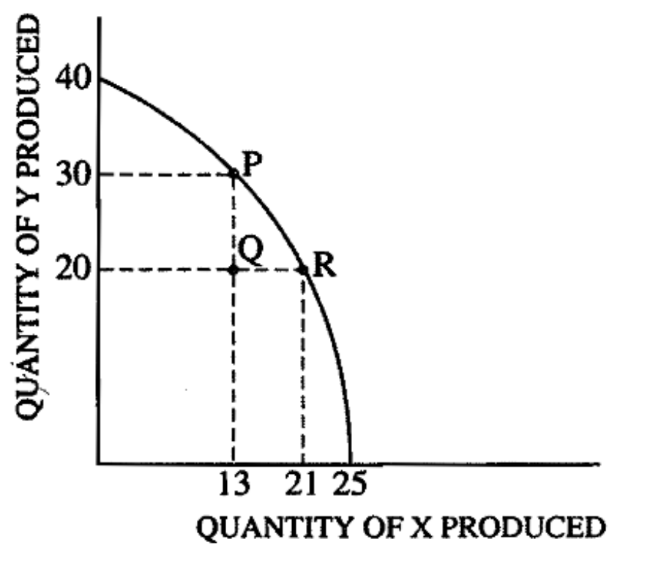

On the basis of the diagram above showing an economy's production possibilities curve for two goods, which of the following statements must be true?

I. The opportunity cost of moving from point P to point R is 10 units of Y.

II. The opportunity cost of moving from point R to point P is 8 units of X.

III. The opportunity cost of moving from point Q to point R is 0 units of Y.

(A) I only

(B) III only

(C) I and II only

(D) II and III only

(E) I, II, and III

1. If a certain combination of goods or services lies outside the production possibilities curve of an economy, which of the following is true?

(A) Effective trade barriers have reduced foreign imports into the economy.

(B) New technology is being used in production.

(C) Resources are not available to achieve that combination of goods or services.

(D) Resources are not being used efficiently to achieve that combination of goods or services.

(E) Resources are being used at a more rapid rate than they were in the past.

1. A production possibilities curve that is concave to the origin (bowed out) implies that as more of a good is produced, the opportunity cost

(A) remains constant

(B) decreases

(C) decreases at first and then increases

(D) increases

(E) increases at first and then decreases

1. Which of the following concepts can be illustrated using the production possibilities curve?

I. Choice

II. Scarcity

III. Price level

IV. Opportunity cost

(A) II only

(B) I and III only

(C) III and IV only

(D) I, II, and IV only

(E) II, III, and IV only

1. Assume an economy produces two goods, capital goods and consumer goods. If the production of capital goods increases in the current period, which of the following will occur for the current and future production possibilities curve(PPC)for consumer goods and capital goods?

(A) A movement along the current PPC and a leftward shift of the future PPC

(B) A movement along the current PPC and a rightward shift of the future PPC

(C) A rightward shift of the current PPC and a leftward shift of the future PPC

(D) A rightward shift of the current PPC and a rightward shift of the future PPC

(E) A movement along the current PPC with no shift of the future PPC

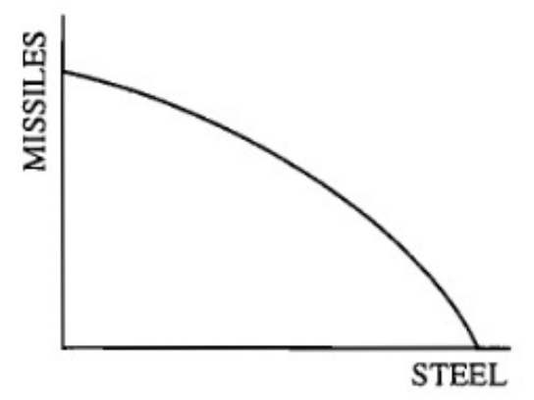

1. Which of the following would cause the production possibilities curve shown above to shift outward?

(A) Reopening steel plants that had been closed

(B) Rehiring laid-off steelworkers

(C) Using machinery for missile production instead of steel production

(D) Using machinery for steel production instead of missile production

(E) Developing a more efficient steelmaking process

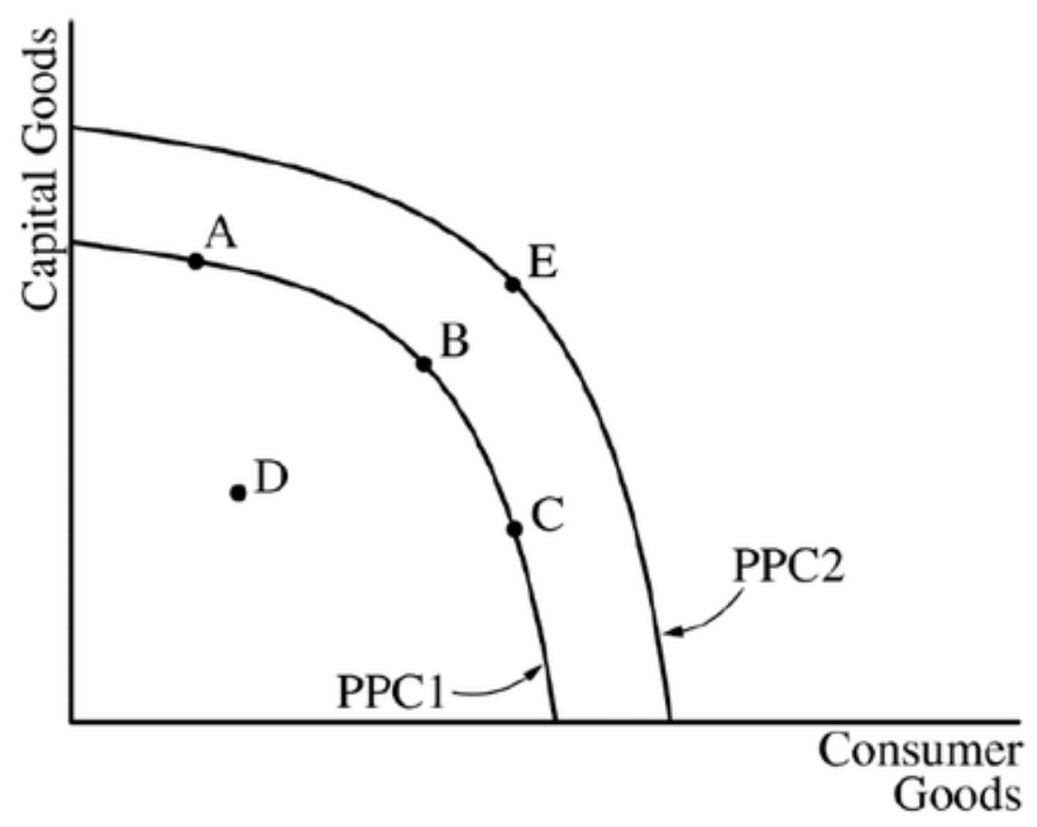

1. The graph above shows the production possibilities curves (PPC) for an economy. The concept of opportunity cost is best represented by which of the following?

(A) A shift from PPC1 to PPC2

(B) A movement from point A to point D

(C) A movement from point B to point C

(D) A movement from point C to point E

(E) A movement from point D to point B

1. If producing each additional unit of good X required giving up ever-increasing amounts of good Y, the production possibilities curve between X and Y would be

(A) bowed outward

(B) bowed inward

(C) a straight line

(D) horizontal

(E) upward sloping

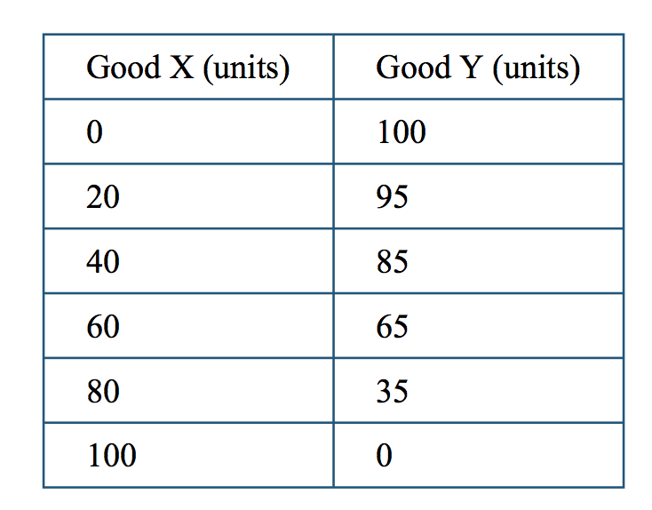

The table above shows the maximum possible output combinations of good x and good 1 that Microland can produce by using all of its available resources and technology. As the production of good x increases, what happens to the opportunity cost of producing good X?

(A) It decreases, because the production of good Y decreases by greater amounts.

(B) It decreases, because the production of good Y increases by smaller amounts.

(C)It remains constant, because the production of good x increases by the same amount,

(D) It increases, because the production of good Y decreases by greater amounts.

(E) It increases, because the production of good Y increases by smaller amounts.

1. Movement along a production possibilities curve shows which of the following?

(A) The trade-offs society faces

(B) The total amount of available resources

(C) The combination of inputs required for a given output

(D) The relationship between the price of an input and the quantity demanded

(E) The decrease in efficiency

**AP Macro 1.3 Comparative advantage**

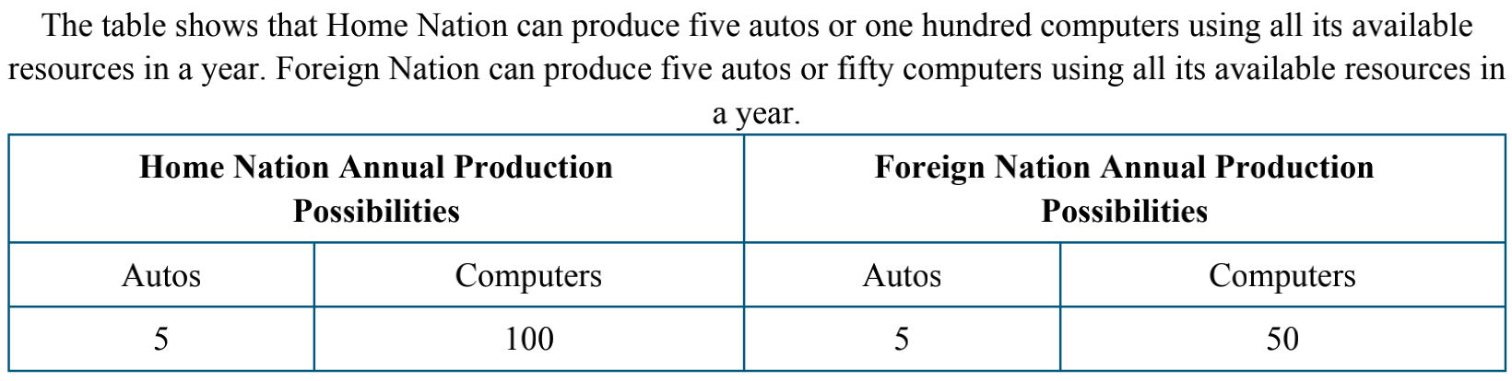

1. Based on the information provided above, which of the following must be true?

(A) Home Nation has an absolute advantage in the production of computers.

(B) Foreign Nation has an absolute advantage in the production of autos.

(C) Home Nation has a comparative advantage in the production of autos.

(D) Foreign Nation has a comparative advantage in the production of computers.

(E) Neither nation has a comparative advantage.

1. Based on the information provided above, which of the following are mutually beneficial terms of trade at which both Home and Foreign Nation will be willing to specialize and exchange?

(A) 1 auto for 1 computer

(B) 1 auto for 10 computers

(C) 1 auto for 17 computers

(D) 1 auto for 20 computers

(E) 1 auto for 25 computers

1. Suppose two countries are each capable of individually producing two given commodities. Instead, each specializes by producing the commodity for which it has a comparative advantage and then trades with the other country. Which of the following is most likely to result?

(A) The two countries will become more independent of each other.

(B) Unemployment will increase in one country and decrease in the other.

(C) There will be more efficient production in one country but less efficient production in the other.

(D) Both countries will become better off.

(E) Both countries will be producing their commodity inefficiently.

Brazil and Peru produce both coffee and wheat using labor as the only input. The table below shows the labor hours required to produce a unit of coffee and a unit of wheat in each country.

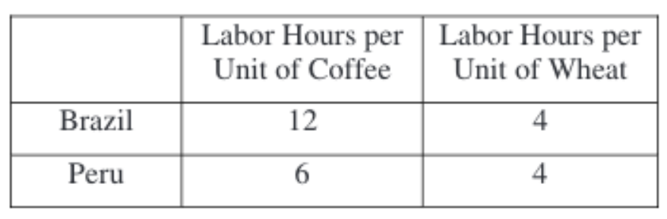

Based on the information in the table above, which of the following is true?

(A) Peru has a comparative advantage in producing wheat.

(B) Peru has an absolute advantage in producing wheat.

(C) Brazil has an absolute advantage in producing wheat.

(D) Peru has a comparative advantage in producing coffee.

(E) Brazil has a comparative advantage in producing coffee.

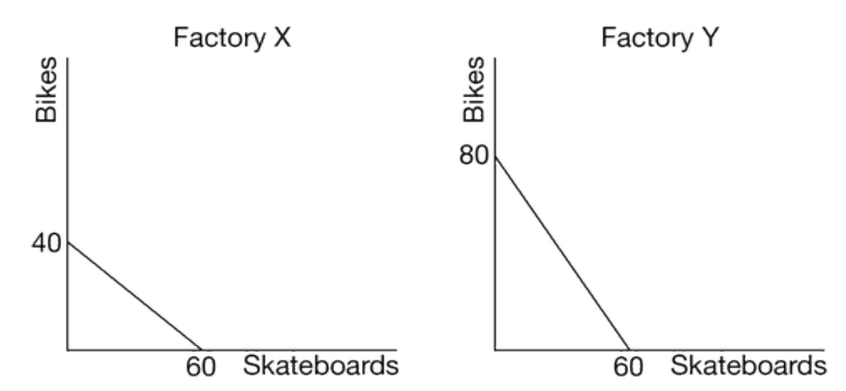

The graph above shows the production possibilities curve for Factory X and Factory Y. If Factory X uses the same amount of resources to produce skateboards and bikes as Factory Y uses, which of the following is true?

(A) Factory X has an absolute advantage in producing bikes.

(B) Factory X has an absolute advantage in producing skateboards.

(C) Factory X has a comparative advantage in producing skateboards.

(D) Factory Y has a comparative advantage in producing skateboards.

(E) Factory Y has an absolute advantage in producing skateboards.

1. Cindy and Martin both sew t-shirts in a small factory. Using the same resources, Martin can sew twelve t-shirts and Cindy can sew nine t-shirts in one day. Which of the following can be concluded from the given information?

  (A) Martin has a higher opportunity cost of sewing t-shirts than Cindy does.

  (B) Cindy has a comparative advantage in sewing t-shirts.

  (C) Martin has a comparative advantage in sewing t-shirts.

  (D) Martin has an absolute advantage in sewing t-shirts.

  (E) Cindy has an absolute advantage in sewing t-shirts.

Country A can produce either 2 tons of cocoa or 4 cars with 10 units of labor. Country B can produce either 5 tons of cocoa or 25 cars with 10 units of labor. Based on this information, which of the following is true?

(A) Country A has an absolute advantage in the production of cocoa, while Country B has a comparative advantage in the production of cocoa.

(B) Country A has a comparative advantage in the production of cocoa, while Country B has a comparative advantage in the production of cars.

(C) Country A has an absolute advantage in the production of cocoa, while Country B has a comparative advantage in the production of cars.

(D) Country A has a comparative disadvantage in the production of both goods.

(E) Neither country has a comparative advantage in the production of either good.

Comparative advantage implies that

(A) no country should specialize completely in the production of any one good

(B) every country should try to export more than it imports

(C) developing countries should import raw materials and export manufactured goods

(D) two countries should benefit from trade unless both have equal opportunity costs in every good

(E) countries should impose tariffs to protect their domestic industries

1. Both Amy and Brad produce and consume apple pie and ice cream. In one hour, Brad makes five apple pies or ten gallons of ice cream while Amy makes fifteen apple pies or fifteen gallons of ice cream. Based on the above information, one can correctly conclude that

 (A) Brad has an absolute advantage in making ice cream and will sell ice cream to Amy

(B) Brad has a comparative advantage in making ice cream and will sell ice cream to Amy

(C) Brad does not have a comparative advantage in making either good and will not trade with Amy

 (D) Brad has an absolute advantage in making apple pies but a comparative advantage in making ice cream

 (E) Brad’s opportunity cost of making ice cream is higher than Amy’s

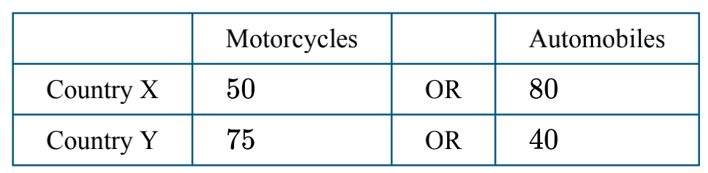

1. The table above shows the quantity of motorcycles and automobiles produced by two countries that use the same amount of resources. Which of the following is true?

(A) Country X has an absolute and comparative advantage in the production of motorcycles.

(B) Country X has an absolute and comparative advantage in the production of both goods.

(C) Neither country has a comparative advantage in the production of motorcycles.

(D) Country Y has an absolute and comparative advantage in the production of automobiles.

(E) Country Y has an absolute and comparative advantage in the production of motorcycles.

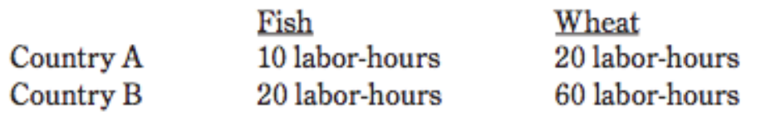

1. The data above indicates labor-hours needed to produce a single unit of each of two commodities in each of two countries. If labor is the only factor used to produce the commodities, which of the following statements must be correct?

  I. Country A has an absolute advantage in the production of both commodities, but a comparative advantage in the production of wheat.

  II. Country B has an absolute advantage in the production of both commodities, but a comparative advantage in the production of fish.

  III. Mutually advantageous trade can occur between the two countries when 2.5 units of fish are exchanged for 1 unit of wheat.

(A) I only

(B) II only

(C) III only

(D) I and III only

(E) II and III only

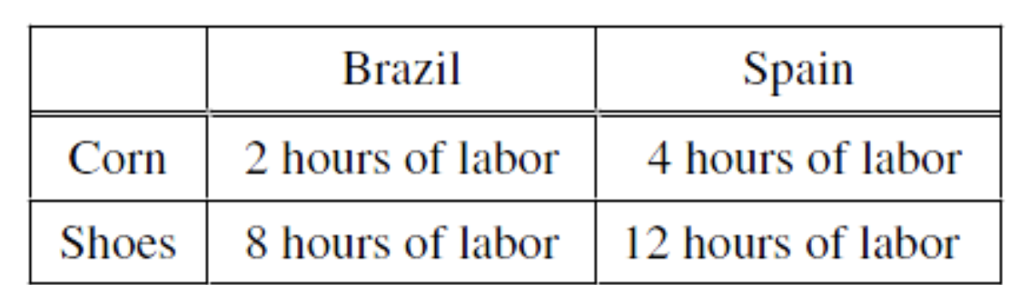

The table above shows the amount of labor required to produce a unit of corn and a unit of shoes in Brazil and Spain. If both countries have equal numbers of workers, what pattern of international trade between Brazil and Spain is most likely to emerge?

(A) Brazil will export both corn and shoes.

(B) Spain will export both corn and shoes.

(C) No mutually beneficial trade can occur.

(D) Brazil will export corn and import shoes.

(E) Brazil will import corn and export shoes.

1. A professor hires two aides, assigning them the tasks of reading student papers and of typing lecture notes on a computer. One of the aides, Ben, can read 1 page of a student paper per minute or type 50 words of lecture notes per minute, and the other aide, Ann, can read 3 pages of a student paper per minute or type 60 words of lecture notes per minute.

Which of the following statements is true?

(A) Ann has a comparative advantage in reading student papers, and Ben has a comparative advantage in typing lecture notes.

(B) Ann has an absolute advantage in reading student papers, and Ben has an absolute advantage in typing lecture notes.

(C) Ben has a comparative advantage in reading student papers, and Ann has a comparative advantage in typing lecture notes.

(D) Ben has a comparative advantage in both reading student papers and typing lecture notes.

(E) Ben has an absolute advantage in both reading student papers and typing lecture note

1. If two nations specialize according to the law of comparative advantage and then trade with each other, which of the following would be true?

(A) A smaller number of goods would be available in each trading nation.

(B) Total world production of goods would decrease.

(C) Everyone within each nation would be better off.

(D) Each nation would increase its consumption possibilities.

(E) One nation would gain at the expense of the other nation.

1. A farmer in Country A can harvest 20 bushels of wheat or 10 bushels of corn in a day, while a farmer in Country B can harvest 8 bushels of wheat or 8 bushels of corn in a day. If Country A and Country B specialize and trade, Country A will

(A) export wheat and import corn

(B) export corn and import wheat

(C) export both wheat and corn

(D) import both wheat and corn

(E) benefit more from trade than will Country B

**AP Macro 1.4 1.5 D&S**

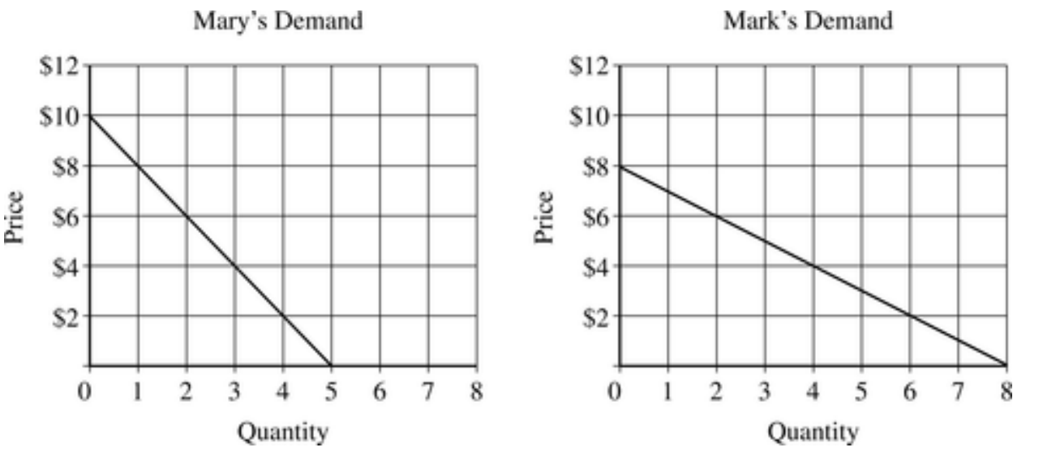

1. The graphs above show Mary’s demand for hamburgers and Mark’s demand for hamburgers. Suppose Mary and Mark are the only two consumers in the market. Which of the following is a point on the market demand curve for hamburgers?

A.

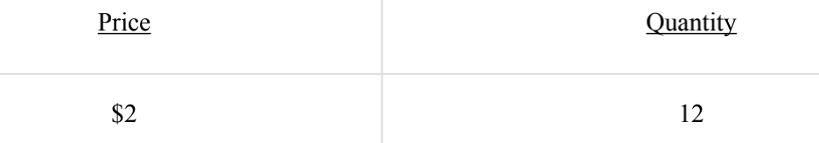

B.

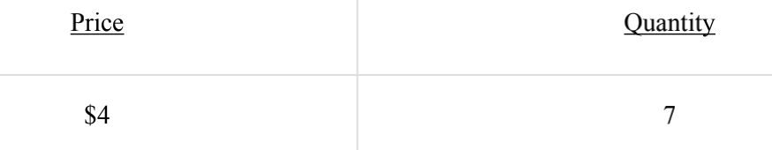

C.

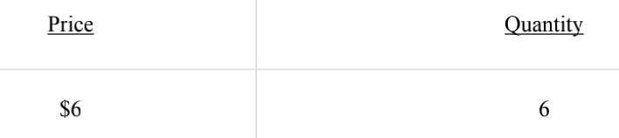

D.

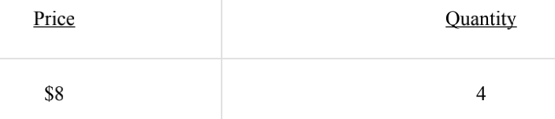

E.

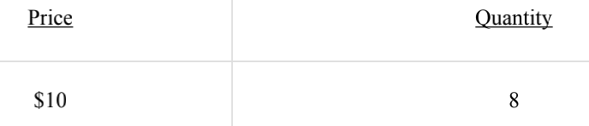

1. All of the following cause a rightward shift in the demand schedule for a normal good EXCEPT

(A) a decrease in the price of the good

(B) a decrease in the price of a complementary good

(C) an increase in the price of a substitute good

(D) an increase in consumers’ income

(E) an increase in consumers’ preference for the good

1. Which of the following will cause the demand curve for good X to shift to the right?

(A) An increase in the price of good Z, a complement to good X

(B) An increase in the price of good Y, a substitute for good X

(C) An increase in the consumer’s income, if good X is an inferior good

(D) A decrease in the price of good X

(E) An increase in the supply of good X

1. Which of the following will decrease the demand for beef?

(A) An increase in the price of pork, if pork and beef are substitute goods

(B) An increase in the price of potatoes, if potatoes and beef are complementary goods

(C) A decrease in the cost of transporting beef to consumers

(D) An increase in the income levels of most consumers, if beef is a normal good

(E) Research showing beef is better for your health than chicken

1. A change in which of the following will cause a change in the supply of personal computers (PC’s) in the short run?

(A) Technology

(B) Demand for PC’s

(C) Price of disks, which are a complement to PC’s

(D) Price of PC’s

(E) Consumers’ incomes

1. Which of the following situations best illustrates the law of demand?

(A) As real incomes of United States citizens have decreased over the past year, the demand for housing has also decreased.

(B) Recent decreases in the price of imported wine have led to an increase in the consumption of domestic wine.

(C) In the past several months, as the price of compact disc players has decreased, the quantity of compact disc players sold has increased

(D) The increase in the price of quality health foods has increased the revenues of firms producing these goods.

(E) As the demand for computers has increased, the number of workers in the computer industry has increased.

1. In a perfectly competitive market, a change in which of the following could cause a shift in the supply curve?

(A) The incomes of consumers

(B) The number of buyers

(C) Technology

(D) The price of the product

(E) Tastes and preferences

1. Which of the following will shift the supply curve for apples to the right?

(A) An increase in consumers’ income

(B) An increase in the price of apples

(C) An increase in the wages of apple pickers

(D) A decrease in the rental price for apple harvesting equipment

(E) A decrease in the demand for oranges, a substitute in consumption

1. An increase in the supply of good X resulted in an increase in the price and quantity of good Y. It can be concluded that good Y is

(A) an inferior good

(B) a luxury good

(C) a normal good

(D) a substitute for good X

(E) a complement for good X

1. Assume that for consumers, pears and apples are substitutes. It is announced that pesticides used on most apples may be dangerous to consumers’ health. As a result of this announcement, which of the following market changes is most likely to occur in the short run in the pear market?

A.

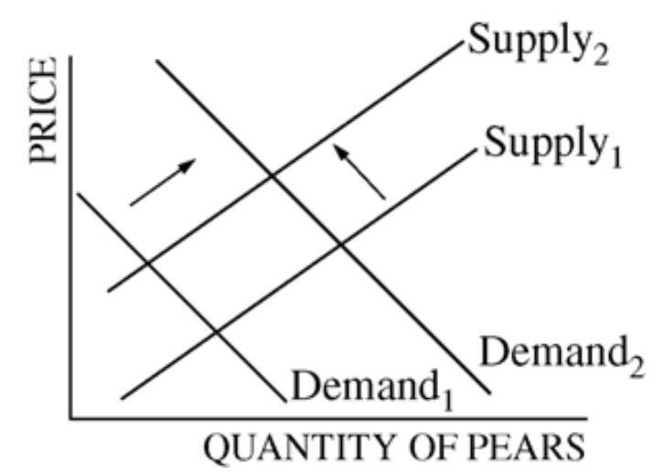

B.

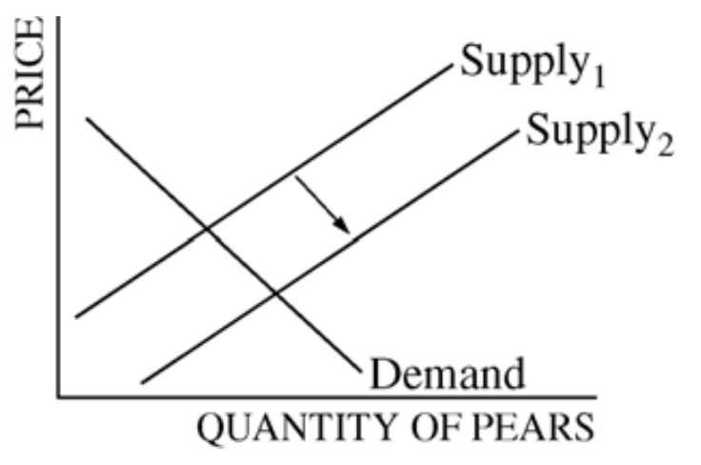

C.

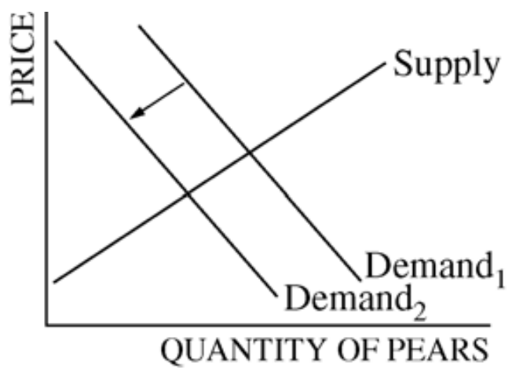

D.

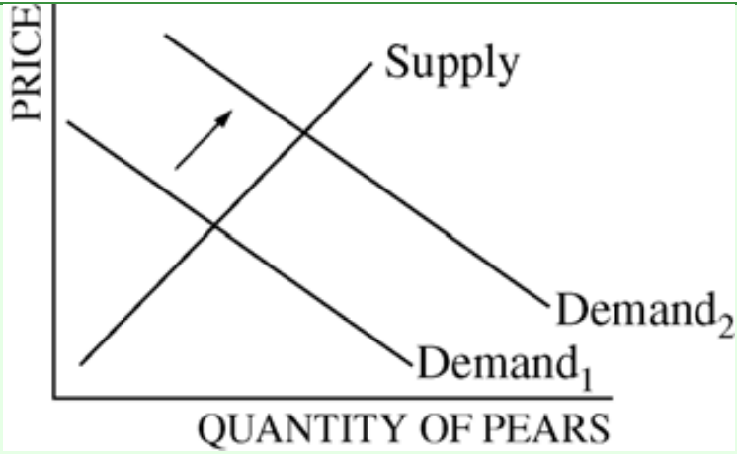

E.

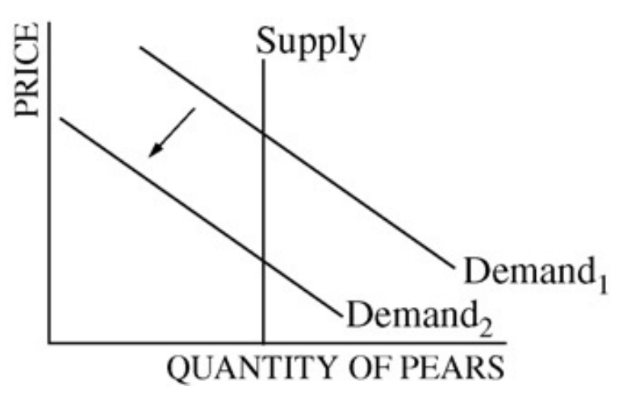

**AP Macro 1.6 Equilibrium**

1.Assume that for consumers, pears and apples are substitutes. It is announced that pesticides used on most apples may be dangerous to consumers’ health. As a result of this announcement, which of the following market changes is most likely to occur in the short run in the pear market?

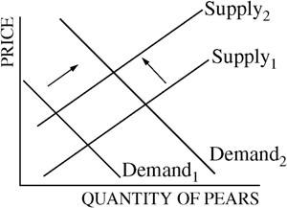(A)

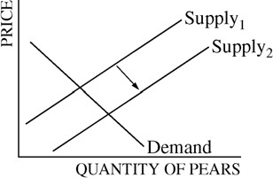(B)

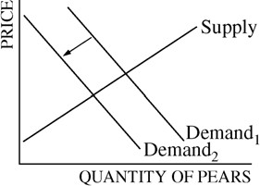(C)

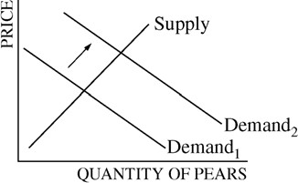(D)

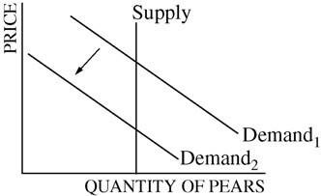(E)

2. Which of the following changes would result in an indeterminate change in the equilibrium price in a competitive market?

(A) An increase in demand and a decrease in supply

(B) An increase in demand and an increase in supply

(C) A decrease in demand and an increase in supply

(D) A decrease in demand with no change in supply

(E) A decrease in supply with no change in demand

3. If there is a decrease in the price of the coffee beans used to make brewed coffee, how will this affect the equilibrium price and quantity of brewed coffee?

(A) Equilibrium price will decrease and equilibrium quantity will increase

(B) Equilibrium price will decrease and equilibrium quantity will not change

(C) Equilibrium price will decrease and equilibrium quantity will decrease

(D) Equilibrium price will increase and equilibrium quantity will decrease

(E) Equilibrium price will increase and equilibrium quantity will not change

4. A leftward shift of the supply curve for computers could be caused by which of the following in the short run?

(A) A decrease in the number of computer manufacturers

(B) A decease in taxes on computer manufacturers

(C) A decrease in the price of computers

(D) A decrease in the price of components used to assemble computers

(E) An increase in the price of mobile devices, a substitute good

5. The diagram above shows two demand curves for video games identified as D1 and D2.

Which of the following changes will most likely cause a shift of the demand curve from D1 to D2 as shown in the diagram?

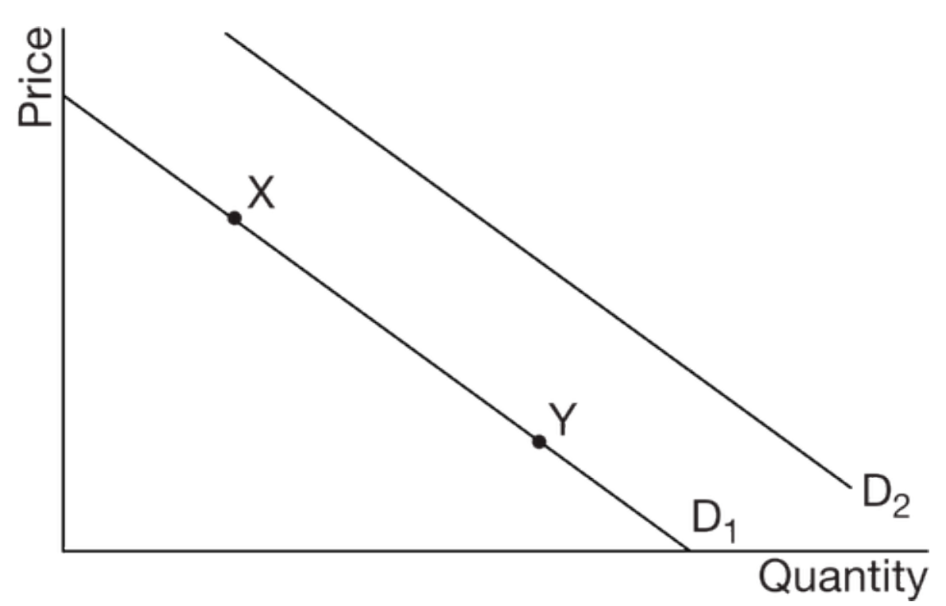

(A) An increase in consumers’ income, assuming that video games are a normal good

(B) An increase in the price of game consoles, a complementary good

(C) A decrease in the price of mobile games, a substitute good

(D) A decrease in the number of buyers in the market

(E) A decrease in the price of video games

6. If the production technology of a good improves and at the same time the number of consumers willing and able to buy the good in the market increases, which of the following will definitely occur?

(A) Equilibrium price will increase.

(B) Equilibrium price will decrease.

(C) Equilibrium quantity will increase.

(D) Equilibrium quantity will decrease.

(E) Equilibrium quantity will remain the same.

7.

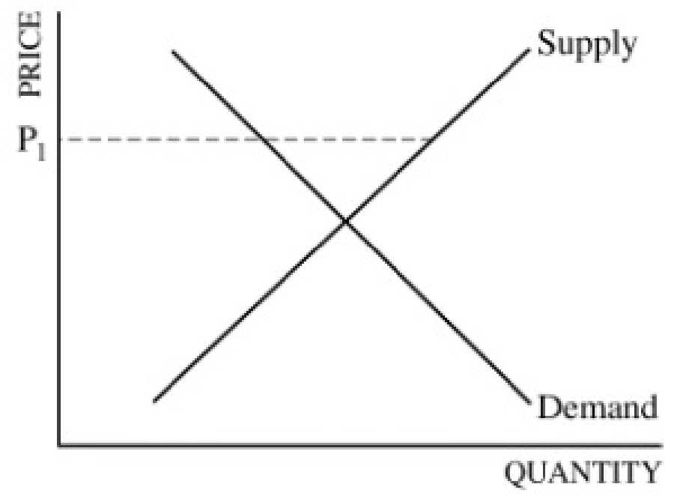

The graph above shows the demand for and supply of a good. If the market price is P1, then

(A) there is a shortage, and the price will rise

(B) there is a shortage, and the price will fall

(C) there is a surplus, and the price will rise

(D) there is a surplus, and the price will fall

(E) demand will decrease and supply will increase

8.

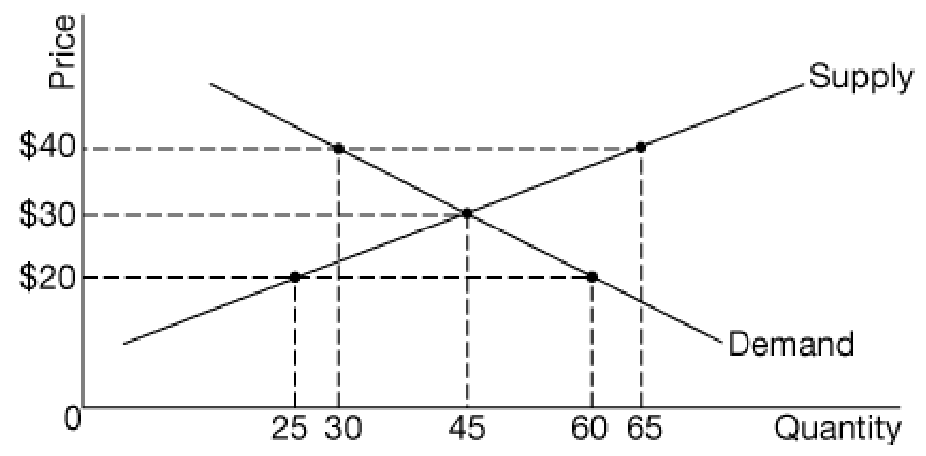

In the competitive market represented by the graph provided, which of the following is true at a price of ?

(A) There is a surplus of 60 units.

(B) There is a surplus of 35 units.

(C) There is a shortage of 60 units.

(D) There is a shortage of 35 units.

(E) The quantity sold equals 60 units.

9.

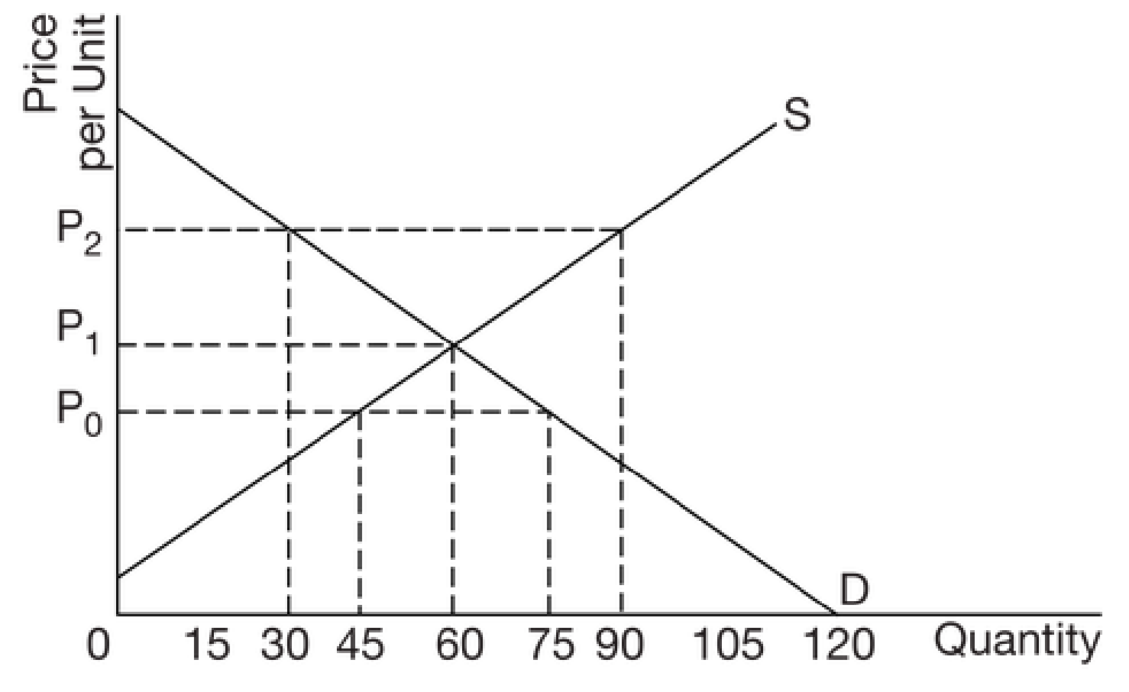  
At a price of P0 in the diagram above, which of the following is true?

(A) The existing surplus in the market will cause upward pressure on prices until equilibrium is reached at 75 units.

(B) The existing surplus in the market will cause downward pressure on prices until equilibrium is reached at 60 units.

(C) The existing shortage in the market will cause upward pressure on prices until equilibrium is reached at 30 units.

(D) The existing shortage in the market will cause upward pressure on prices until equilibrium is reached at 60 units.

(E) The existing shortage in the market will cause downward pressure on prices until equilibrium is reached at 45 units.

10. At a price of P2 in the diagram above which of the following will happen in the market?

(A) There will be a surplus of 30 units and 90 units will be exchanged.

(B) There will be a surplus of 90 units and 30 units will be exchanged.

(C) There will be a surplus of 60 units and 30 units will be exchanged.

(D) There will be a shortage of 90 units and 30 units will be exchanged.

(E) There will be a shortage of 30 units and 90 units will be exchanged.